Instruction Manual No. 20 JVD
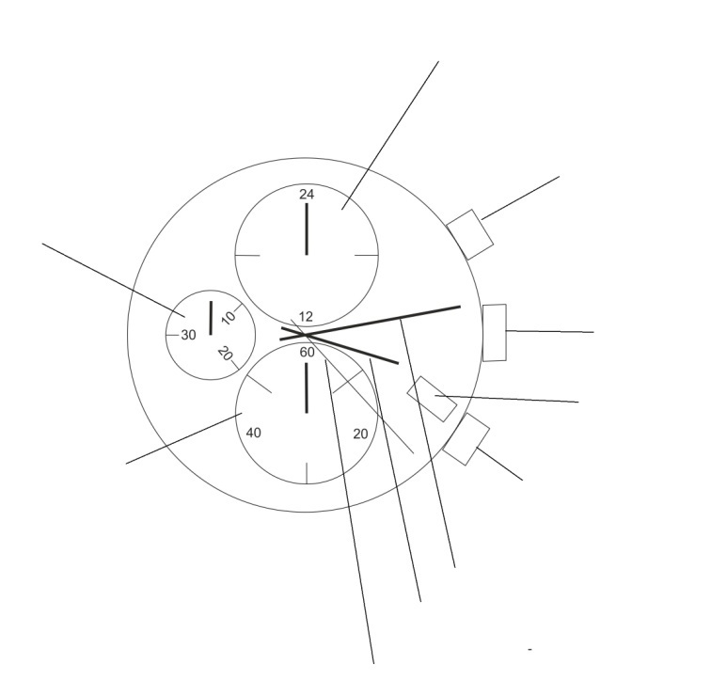
- The dial
24-hour hand

Button A
Stopwatch – minutes

Crown (position 0) 1 2
Date

Stopwatch – seconds
Button B

Minute hand
Hour hand
Second hand

- Time setting
1. Pull crown out to position 2. Second hand stops moving.
2. Turn crown to advance hour and minute hands.
3. Push crown back to initial position. Second hand starts moving.
- Date setting
- Pull crown out to position 1.
- Turn crown clockwise until you have set the correct date. Do not set the date between 09:00 PM and 01:00 Am – the date would change at noon instead of at night.
- Push crown back to initial position.
- Using stopwatch
1. Press button A once to start/stop stopwatch.
2. Press button B to reset stopwatch. All hands will return to initial position.
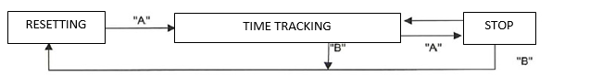
- Resetting stopwatch (e.g. after battery replacement)
Follow these instructions if the second hand of the stopwatch does not return to 00:00 after the reset of the stopwatch (e.g. after battery replacement).
1. Pull crown out to position 2.
2. Press button A to set second hand of the stopwatch to position 00:00.
3. You can speed up the process by holding buttons A or B.
4. When the second hand is at 00:00, set time and push crown back to initial position.
*Do not push crown back to initial position unless the second hand is at 00:00.
*If you pushed the crown before the second hand reaches 00:00, the second hand would stop and the point at which it stopped would be set as the new initial point (00:00).

